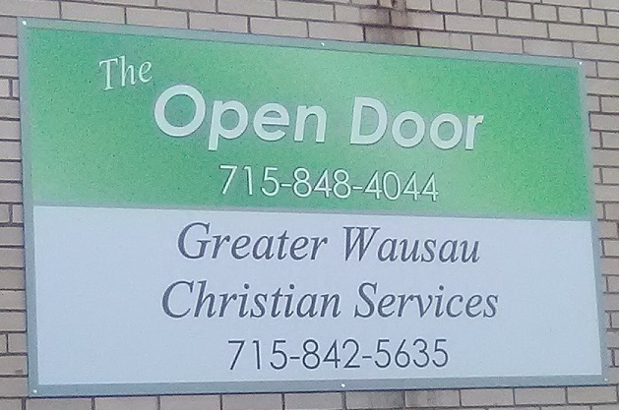
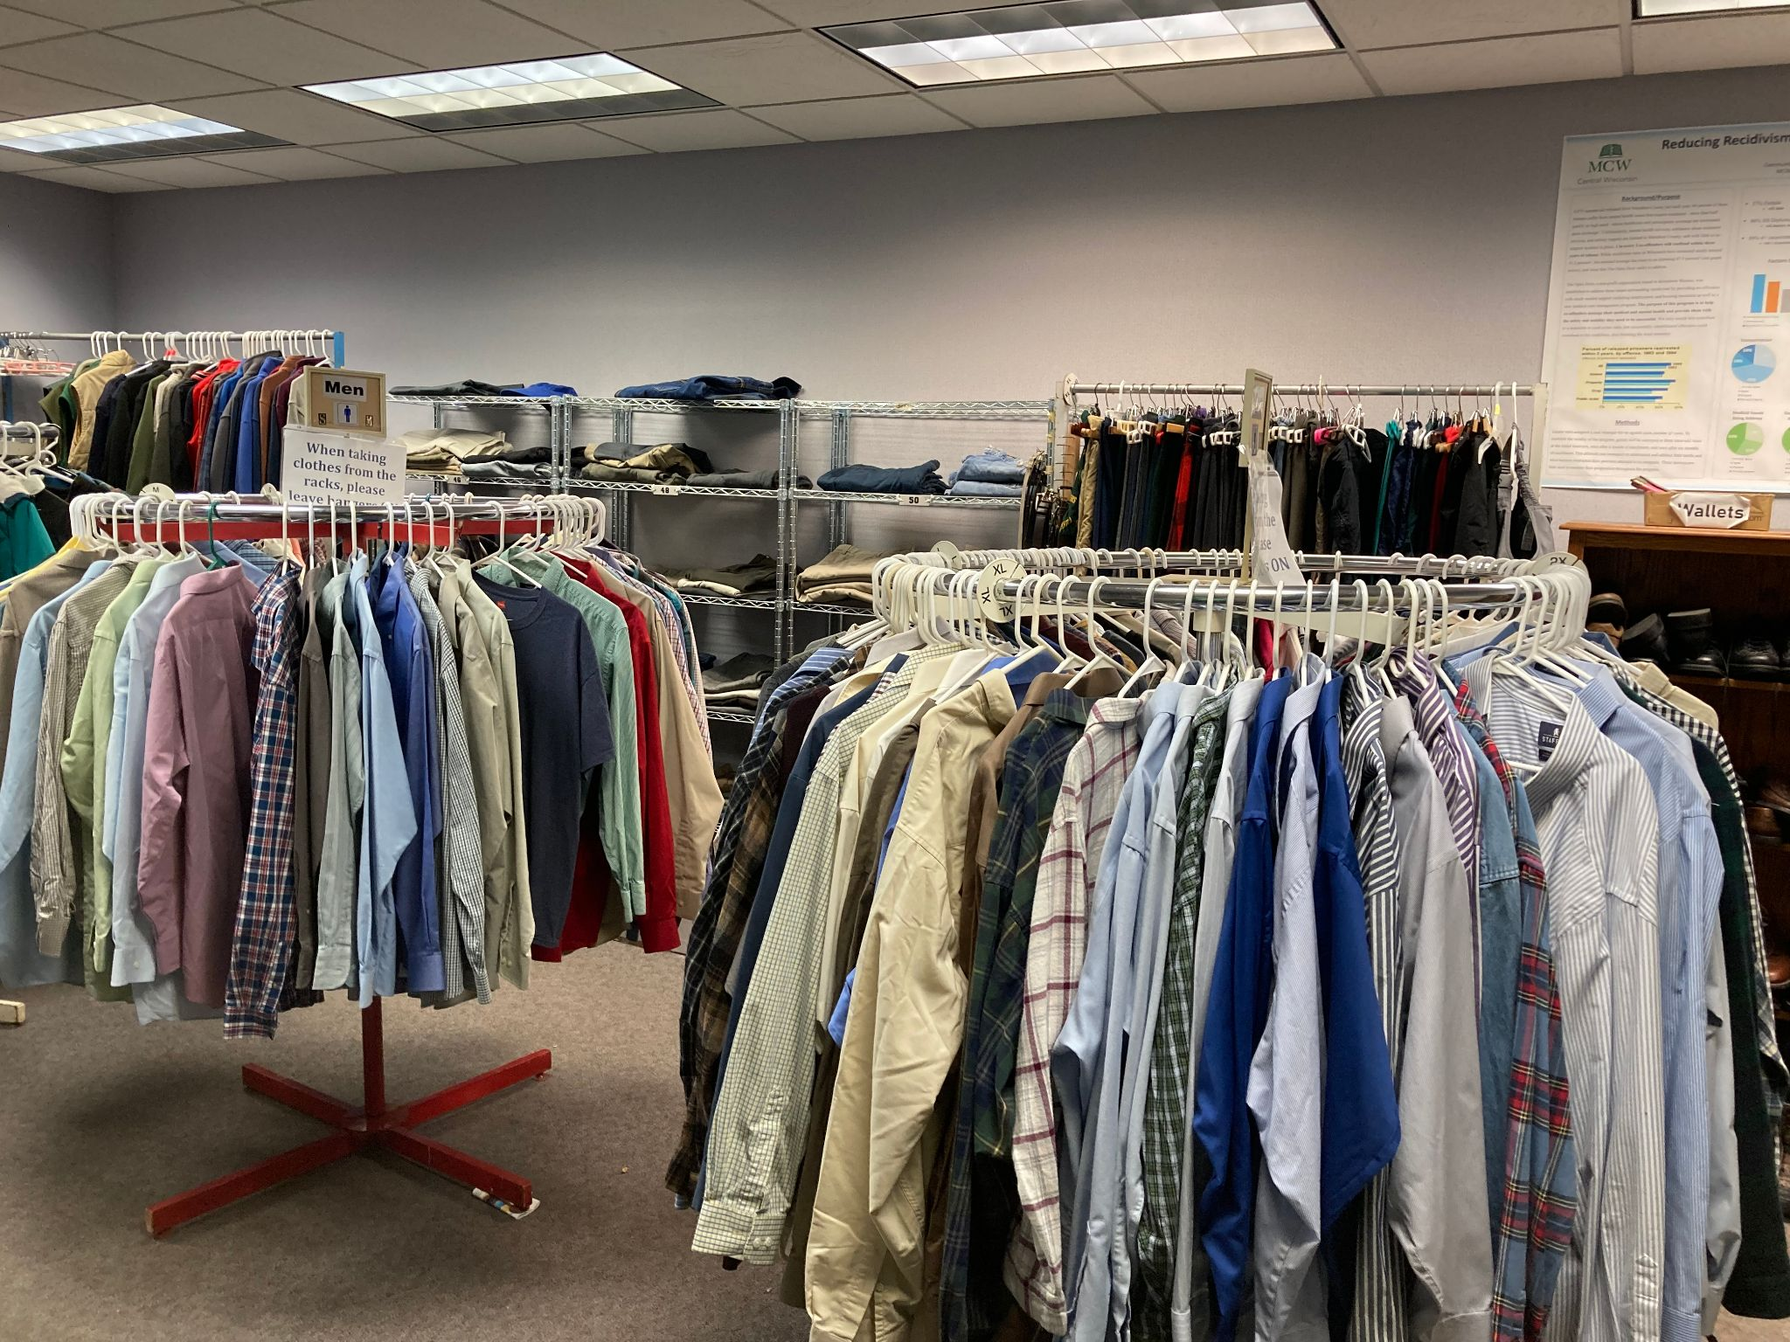
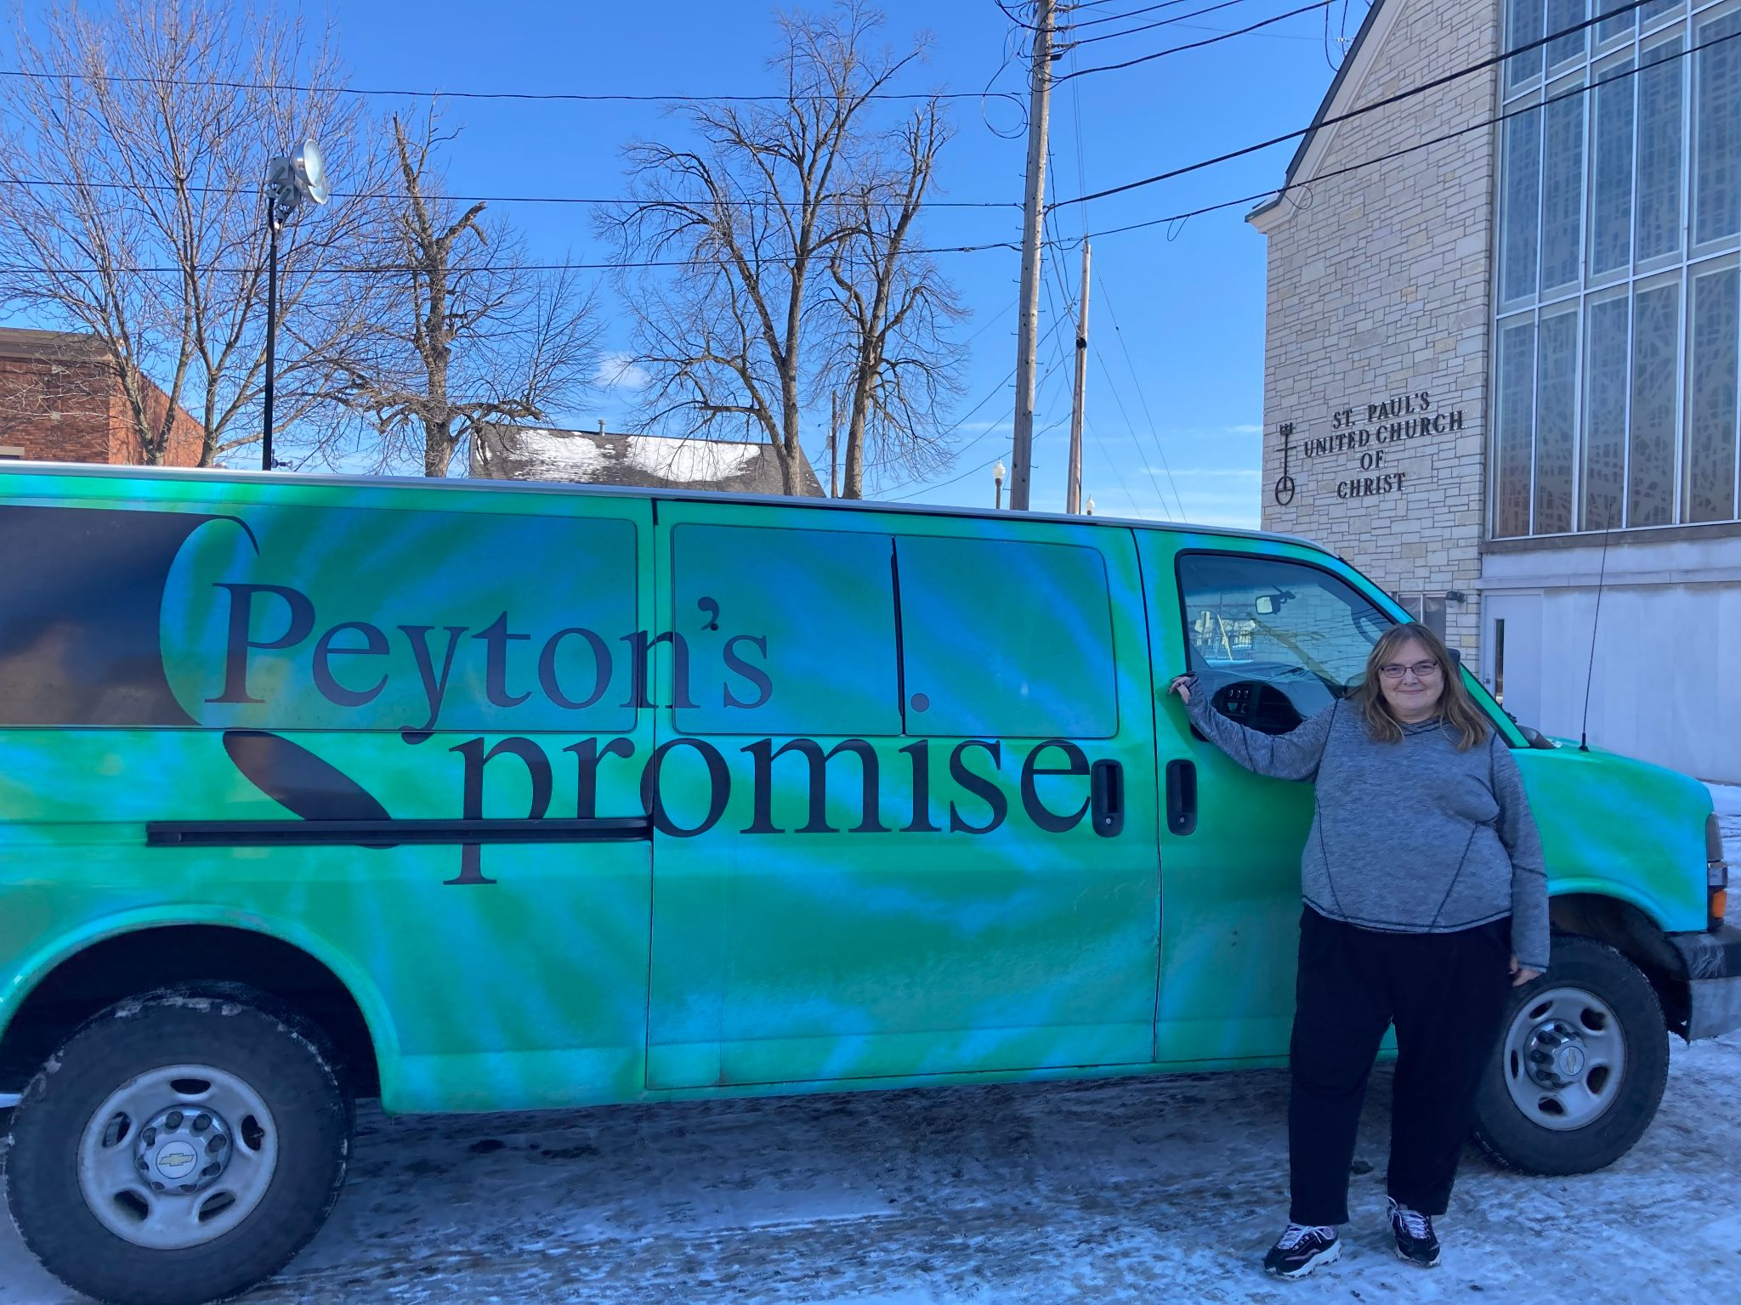

“The Open Door is organized to provide charitable and educational services to meet the immediate needs of individuals who are incarcerated and /or who have been released from prison"

Who: The Open Door of Marathon County offers temporary help to current and newly released inmates and people who are struggling with financial insecurity, and housing insecurity by providing clothing, and a safe place once released from jail to have a coffee, socialization with volunteers, and access to resources available to them. Two of those resources are The Making Amends classes and Partner Project. One of the educational components is the Life Skills and Job Readiness Training classes offered to inmates who are on Huber Law and currently incarcerated, and now for selected individuals a case worker.

What: The Open Door is a community based collection of volunteers and community members dedicated to providing service, support and a helping hand to currently released inmates and individuals who are struggling with life circumstances. They also provide Life Skills and Job Readiness Training Classes, Making Amends Classes, Partner Project and referral resource services in a friendly, non-threatening environment. The ability to connect with people is entirely based on the volunteer efforts of all involved and community support.

Where: The Open Door Of Marathon County 319 4th Street, Wausau, WI 54403
The entrance will have a green “The Open Door” sign facing south on 5th Street, you pull in right behind St. Paul's church on the corner of 5th Street and Washington in downtown Wausau.

When: M-F 5:00am to 12:00pm Sat. & Sun. 5:00am to 10:00 am (including Holidays) 365 days a year.

